A picture containing indoor

Description generated with high confidence

[Type the document title]

[Type the document subtitle/type]

[Type the company name]

Version [X.X]

А Я тут фічу нову додав!!!

\

Contents

1 Document overview 3

1.1 Terminology 3

1.2 References 3

2 Heading 1 4

2.1 Heading 2 4

2.1.1 Heading 3 4

3 About 2018 template 6

3.1 Fonts 6

3.2 Styles in Microsoft Word 6

3.3 No manual formatting 7

4 Styles in this template 7

4.1 Styles for paragraphs and characters 7

4.2 Styles for lists 7

4.3 Styles for tables 8

4.4 Styles for images 9

Revision history

| Date | Version | Description | Author |
| --- | --- | --- | --- |
| MM/DD/YYYY | <X.X> | <details> | <Name> |
| MM/DD/YYYY | <X.X> | Approved | <Name> |
|  |  |  |  |

# Document overview

Lorem ipsum dolor sit Lorem ipsum dolor sit Lorem ipsum dolor sit Lorem ipsum dolor sit Lorem ipsum dolor sit Lorem ipsum dolor sit Lorem ipsum dolor sit Lorem ipsum dolor sit Lorem ipsum dolor sit Lorem ipsum dolor sit Lorem ipsum dolor sit Lorem ipsum dolor sit

## Terminology

|  |  |
| --- | --- |
| Term | Definition |
|  |  |
|  |  |
|  |  |

## References

| # | Version | Date | Name | Published by |
| --- | --- | --- | --- | --- |
| 1 | <X.X> | MM/DD/YYYY | <Document name> | <Publishing organization> |
|  |  |  |  |  |
|  |  |  |  |  |

# Heading 1

Lorem ipsum dolor sit Lorem ipsum dolor sit Lorem ipsum dolor sit Lorem ipsum dolor sit Lorem ipsum dolor sit Lorem ipsum dolor sit Lorem ipsum dolor sit Lorem ipsum dolor sit.

## Heading 2

Lorem ipsum dolor sit Lorem ipsum dolor sit Lorem ipsum dolor **Lorem ipsum dolor** ipsum dolor sit Lorem ipsum dolor sit Lorem ipsum dolor sit Lorem ipsum dolor.

### Heading 3

Lorem ipsum dolor sit Lorem ipsum dolor sit Lorem ipsum dolor sit Lorem ipsum dolor sit Lorem ipsum dolor sit Lorem ipsum dolor sit Lorem ipsum dolor sit Lorem ipsum dolor sit Lorem.

#### Heading 4

Lorem ipsum dolor sit Lorem ipsum dolor sit Lorem ipsum dolor sit Lorem ipsum dolor sit Lorem ipsum dolor sit Lorem ipsum dolor sit Lorem ipsum dolor sit Lorem ipsum dolor sit.

1. Lorem ipsum dolor sit Lorem ipsum dolor sit Lorem ipsum dolor sit Lorem ipsum dolor.

Lorem ipsum dolor sit Lorem ipsum dolor sit **Lorem ipsum** dolor sit Lorem ipsum dolor sit Lorem ipsum dolor sit Lorem ipsum dolor sit Lorem ipsum dolor sit Lorem ipsum dolor.

1. List Number 1
2. List Number 1

Lorem ipsum dolor sit Lorem ipsum dolor sit Lorem ipsum dolor sit Lorem ipsum dolor sit Lorem ipsum dolor sit Lorem ipsum dolor sit Lorem ipsum dolor sit Lorem ipsum.

1. List Number 2
2. List Number 2
3. List Number 3
4. List Number 3

* List Bullet 1
* List Bullet 1

Lorem ipsum dolor sit Lorem ipsum dolor sit Lorem ipsum dolor sit Lorem ipsum dolor sit Lorem ipsum dolor sit Lorem ipsum dolor sit Lorem ipsum dolor sit.

* List Bullet 1
* List Bullet 2
* List Bullet 2
* List Bullet 3
* List Bullet 3

Lorem ipsum dolor sit Lorem ipsum dolor sit Lorem ipsum dolor sit Lorem ipsum dolor sit Lorem ipsum dolor sit Lorem ipsum dolor sit Lorem ipsum dolor sit Lorem ipsum dolor sit Lorem ipsum dolor sit Suspendisse egestas urna consequat, consectetur lacus at, dignissim ipsum.

Lorem ipsum dolor sit Lorem ipsum dolor sit Lorem ipsum dolor sit Lorem ipsum sit. Lorem ipsum dolor sit Lorem ipsum dolor sit Lorem ipsum dolor sit Lorem ipsum dolor sit Lorem ipsum dolor sit.

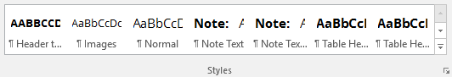

Image caption

Lorem ipsum dolor sit Lorem ipsum dolor sit Lorem ipsum dolor sit Lorem ipsum dolor sit Lorem ipsum dolor sit Lorem ipsum dolor sit Lorem ipsum dolor sit Lorem ipsum dolor sit Lorem ipsum dolor sit.

# About 2018 template

This template was designed by [Technical Communication Office (TCO)](mailto:TechnicalCommunicationOffice@softserveinc.com) to follow SoftServe 2018 brand guidelines. Starting from February 2018, you must use this and not old SoftServe document templates.

We developed and tested this template thoroughly to make sure all SoftServians have nice and consistent documents without extra efforts. Your task would be to simply follow the styles and not to break it 😊. The following sections cover how to use the template effectively and spend as little time as possible to make your document look wonderful.

## Fonts

To ensure the document look exactly as it was designed, make sure you have the following fonts installed on your computer. If the fonts are missing, you can download them from [here](http://bit.ly/2CWuwXe).

* Open Sans Regular
* Proxima Nova Black

1. When sharing your document with clients, better save it as a PDF file to ensure the clients see your document in the exact same way as you do.

## Styles in Microsoft Word

Microsoft Word has a powerful feature called **styles**—a feature that makes formatting much quicker and less complicated. A style is a set of formatting instructions, such as the font size, color, spacing, and others that were saved so you do not have to manually format each section of your document.

With styles, Word identifies different parts of your document (this is how you can see headings and subheadings in the **Navigation** pane and how automatic Table of Contents is created).

To view styles available in this template:

1. On the **Home** tab, in the **Styles** group, click .  
   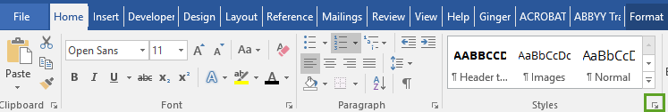
2. In the opened pane (on the right), view the available styles and assign them to the needed paragraphs or words of your document.

For more information about styles in Word, [watch our video tutorial](https://confluence.softserveinc.com/download/attachments/186259652/Master%20Your%20Skills%20in%20Templates.mp4), [read Microsoft help](https://support.office.com/en-us/article/choose-a-quick-style-set-for-a-document-a1f3cd51-9cd8-400d-9082-d96b1ee6eb9c), and simply ask google about it 😊.

## No manual formatting

We kindly ask you to stop using manual formatting options in Microsoft Word. Just forget about them, and use styles instead. **All formatting and fixing should be done using styles.**

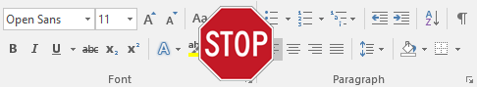

# Styles in this template

Every piece of text should have a certain style applied being a paragraph, list, table, image, or any other piece of content.

## Styles for paragraphs and characters

This text has a **Body Text** style applied. The name Body Text in the previous sentence has a **Strong** style applied to make it look as a bold text. There are styles for the whole paragraphs and for a piece of text.

1. This is a note that has **Note Text** style applied.

If you need to have a link in your document, it will look like this, having a **Hyperlink** style assigned automatically.

## Styles for lists

All lists (both ordered/numbered and unordered/bulleted) also have styles for each level of the list. Just look:

* This line has **List Bullet** style assigned
* This line has **List Bullet 2** style assigned
* This line has **List Bullet 2** style assigned
* This line has **List Bullet** style assigned

Ordered lists work in the same way:

1. This line has **List Number** style assigned
2. This line has **List Number 2** style assigned
3. This line has **List Number 2** style assigned
4. This line has **List Number** style assigned

You can use a mixture of styles for your needs, for example, if you need to insert a note in the middle of a procedure that refers to certain list item only, use **Note Text Indented** style.

* This line has **List Bullet** style assigned

This line has **Note Text Indented** style assigned

## Styles for tables

Tables also need to have styles assigned. When creating a new table, it will look like this.

|  |  |  |
| --- | --- | --- |
|  |  |  |
|  |  |  |

If for some reason it doesn’t look like above, click anywhere in the table, and then, on the **Design** tab, select the **Table_black** style.

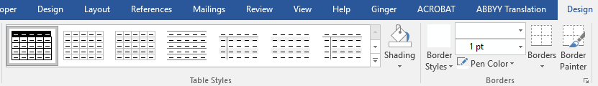

When entering a text on your table, note that there are styles designed for tables specifically:

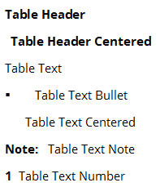

Check out the following table to see how this works.

| Table Header | Table Header | Table Header |
| --- | --- | --- |
| Table Text | Table Text Table Text Table Text Table Text Table Text | Table Text Table Text Table Text Table Text Table Text |
| Table Text | Text Table Text Table Text Table Text Table Text  Table Text Note | 1. Table Text Number Table Text Number Table Text Number 2. Table Text Number |
| Table Text Table Text | Table Text Table Text Table Text Table Text Table Text Table Text Table | * Table Text Bullet * Table Text Bullet |
| Table Text | Table Text Table Text Table Text Table Text Table Text Table Text Table Table Text Table Text Table Text Table Text Table Text Table Text Table | Table Text Table Text Table Text Table Text Table Text Table   * Table Text Bullet * Table Text Bullet |

## Styles for images

For images, use **Image** style to make it center aligned. For image captions, use **Caption** style.

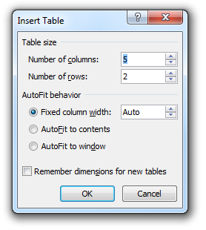

Image caption

If you need to have images aligned with the text, use same style as for the text proceeding   
the image, for example, **Body Text** or **Body Text** **Indent**.